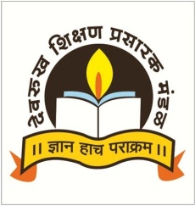Devrukh Shikshan Prasarak Mandal's

**Nya. Tatyasaheb Athalye Arts, Ved. S.R. Sapre Commerce and Vid. Dadasaheb Pitre Science College (Autonomous)**

Late Kakasaheb Pandit Educational Campus, Devrukh, Dist: Ratnagiri- 415 804, Maharashtra

-----------------------------------------------------------------------------------------------------------------------------------------------------------

**MAJOR RESEARCH PROJECTS**

|  |  |  |  |  |  |
| --- | --- | --- | --- | --- | --- |
| **Sr.**  **No.** | **Principal Investigator** | **Title of the project** | **Funding**  **Agency** | **Duration** | **Amount**  **Sanctioned** |
| 1. | **Dr. Hemant V. Chavan** | Development of Practical Synthetic Approaches to Dragmacidins G, H, and their Analogues: Studies toward the Finding of Highly Potent Antimicrobial and Anticancer Agents | DST-SERB, India | 14th November 2018  To  31st March 2022 | 18.30 Lakh |